KKS5 -

Functionality
You use this transaction to calculate the variances for all product cost collectors in a plant.
The system compares the control costs with the target costs and assigns the variances to variance categories.
Target cost version 0 is used to explain the difference between the debit and credit of the product cost collector or manufacturing order. The target costs calculated on the basis of the current standard cost estimate are compared with the actual costs from which the work in process has been deducted. The difference is assigned to different variance categories depending on the cause. Only the variances calculated with target cost version 0 can be transferred to Profitability Analysis (CO-PA).
With target cost version 1, production variances for the product cost collector are calculated using the target costs determined on the basis of the preliminary cost estimate for the product cost collector. If you are using a product cost collector, the target costs cannot be determined on the basis of the preliminary cost estimate for the manufacturing order. Target cost version 1 is used for informational purposes. It cannot be settled.

Scenario
At month end, you want to calculate the variance of all products cost collectors in a specific plant.

Requirements
Product cost collectors were created. WIP was calculated.

Menu Path | Accounting → Controlling → Product Cost Controlling → Cost Object Controlling → Product Cost by Period → Period-End Closing → Single Functions: Product Cost Collector → Variances → KKS5 - Collective Processing
Transaction Code | KKS5

1. Double click on KKS5 - Collective Processing.

Variance Calculation: Initial Screen

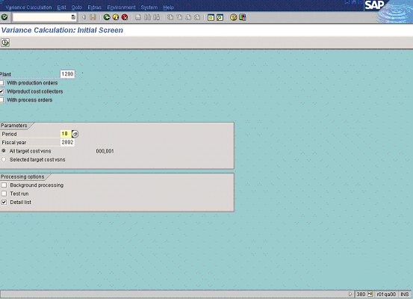

2. Update the following fields:

Field Name | Field Description | Values
Plant | Code identifying the operational unit of the company where the material is manufactured and stored | Example: 1200
Period | Number identifying a fiscal month. | Example: 10
Fiscal year | Number identifying a fiscal year. | Example: 2002

3. Click the All target cost versions radio button.
4. Click the Test run checkbox to deselect.
5. Click the Detail list checkbox to select.
Variance Calculation: List

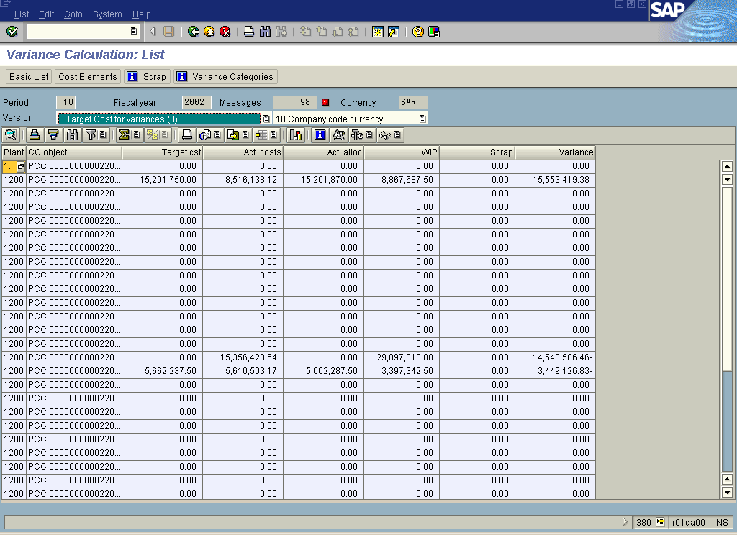

6. Click the Cost Elements button.
Variance Calculation: List

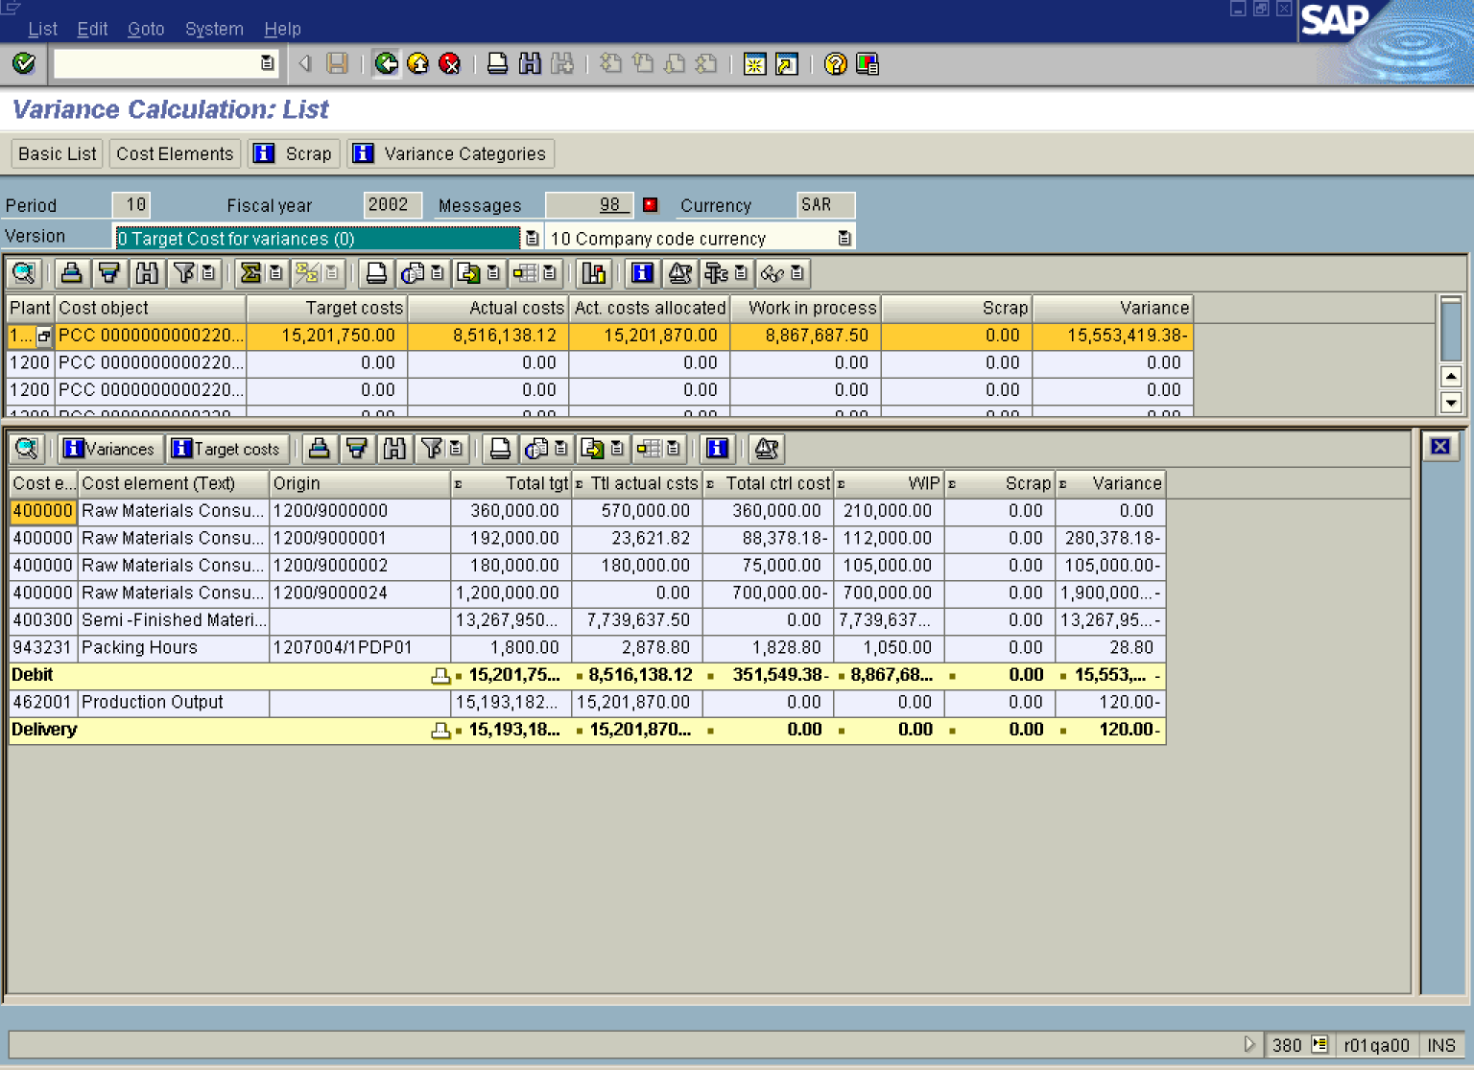
7. Select the line.
8. Click the Variance Categories button.

Variance Calculation: List

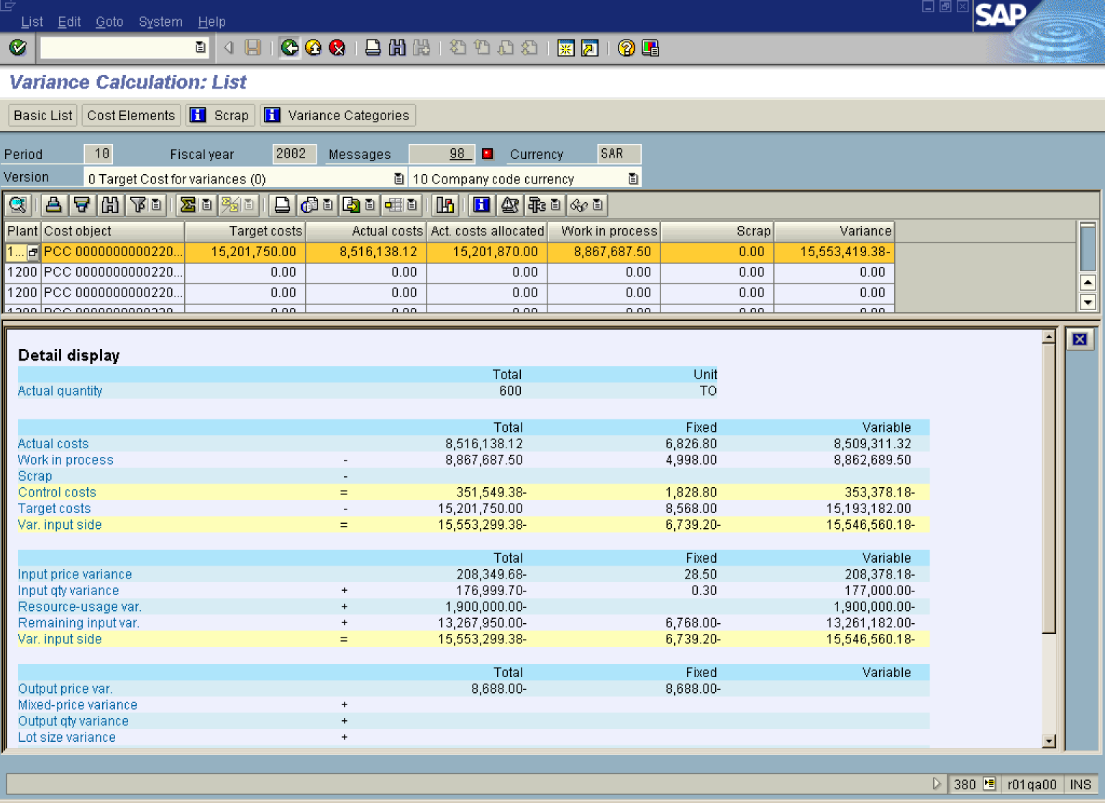

9. Click the Back button.
Variance Calculation: List

10. Click the Back button.

Variance Calculation: List

11. Click the Back button.

